Installation instructions for Lower
Page 1 of 1
Item # 523 Lower Fat Fork Covers Victory Cross Country and Cross Road. Item # 524 Upper Fat Fork Covers Victory Cross Country and Cross Road.
To do this install you will need a service Manuel, Tube of Clear Silicon, Bike lift to get the front of the bike off the ground and a few hand tools. There is a 16MM Allen Wrench required to get the front wheel bolt off.
After the front of the bike is off the ground and stable you need to take the Front Fender, Front Wheel, Front Brake Calipers and Forks off the bike per the service Manual.
You can take the forks off the bike one at a time so you don’t have one laying around to trip over.
Once you have one of the forks in your hand clean it real good.
The 523 Lower tube will be put on first using one Large O-Ring and one Small O-ring that came with the tubes. (see photo #1)
You will slide the Large O-Ring over the fork first all the way down to the Fork bell. (see photo #2)
Now take one of the Lower tubes and look into both ends you will see that one end has a larger bore with a step in it, the side with the step goes over the bell of the fork. (see photo #3)
You will feel the step come into contact with the O-Ring, you will need to apply a little pressure to seat the tube onto the bell of the fork.
You will know that the Lower Tube has been properly seated when the bottom of the tube is even with the black seal on the fork.
The small O-Ring goes on next (see photo #4)
Now we will need to get the 524 Upper Fat Fork tube ready to install by applying some Clear silicon about a 1/2inch deep into each end of the upper tube. You do not need to overdo just a small band using your finger tip around the inside is plenty. (see photos #5 & 6)
Now it’s time to re-install the fork by inserting it back through the lower tree, you will need to hold the upper tube between the trees while you slide the fork all the way up into the upper tree. (see photo #7)
Torque the 8MM bolts per the Service Manual and twist the upper tube just a bit to spread the silicone a little, it will take the silicone about 24 hours to cure.
Now repeat the process for the other front fork.
With both forks re-installed and torqued per the service Manual specs it’s time to re-install the Wheel, Calipers and Front fender per the service Manual.
Now double check that you have re-installed everything per the Manual, Pump the Front Brakes a few times to make sure you have the Front Brake Pads re-set and as soon as the silicone is dry clean her up and send me some pictures jason@victoryonly.com now it’s time to ride!!!!!
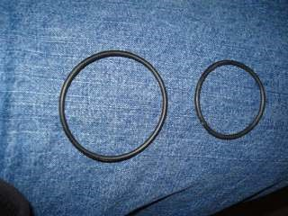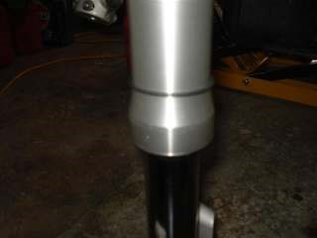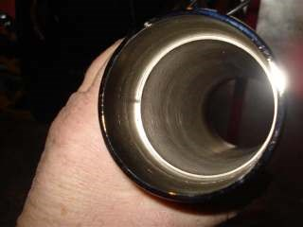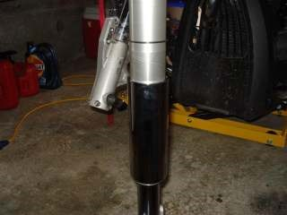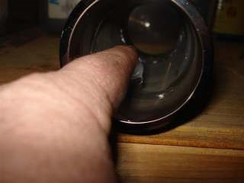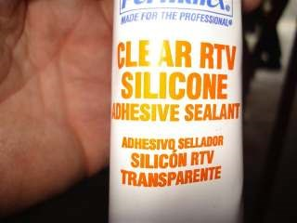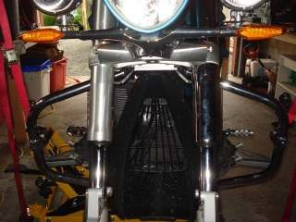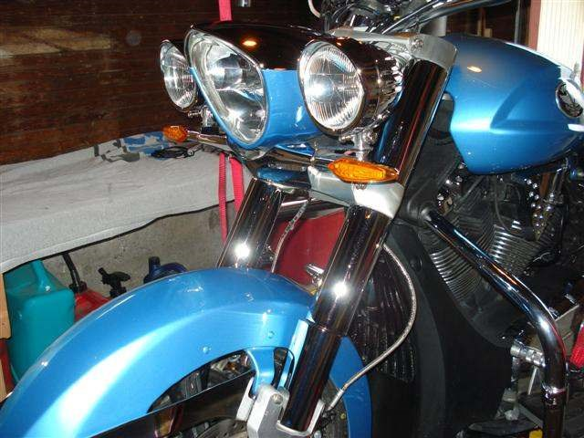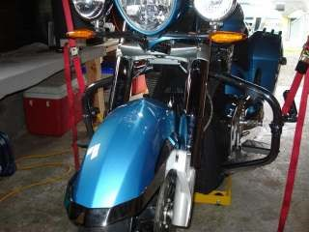
1
2
3
4
5
6
7

