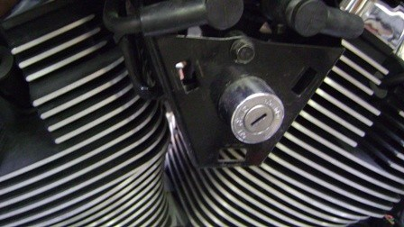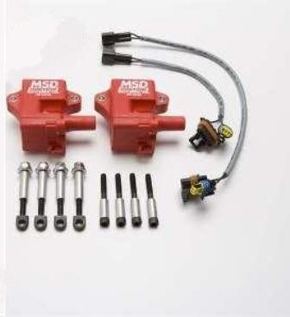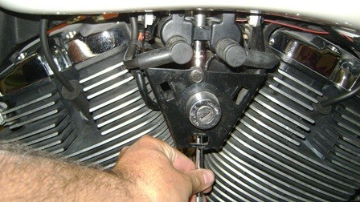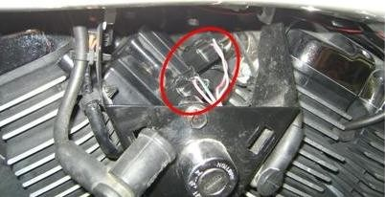

Victory Motorcycle

MSD Coil Kit

www.victoryonly.com

Warning:

Do not install with the motor warm. This is an install at your
Own risk product. If you are not capable of installing it success-
Fully then we suggest you take this item to a professional shop.

1
-
Remove left cheese wedge by pulling it off. (fig. 1)

Fig. 1

Fig. 3 Fig. 2
2- It’s not necessary to remove the cheese wedge mount bracket & ignition key cylinder unless you plan on relocating the ignition. Disconnect the spark plug wires from the coils. With a long extension & 10 mm socket, reach up behind the ignition key cylinder and unscrew the bolt holding the coils to the mount. (fig. 2) Once loose, disconnect the factory wiring from the coils & set the coil pack aside. (fig. 3)
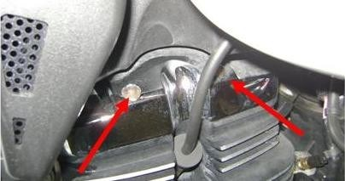

3-With a 5mm allen wrench remove the 2 valve cover bolts on each cylinder. (fig. 4) (People say taking the gas tank bolts loose and lifting it up a bit will help to gain easier access to the bolts but its not necessary.
Fig. 4

